**3D2N Hongkong FIT & Optional Tour**





# Menginap di HOTEL PRUDENTIAL HONG selama (02) dua malam

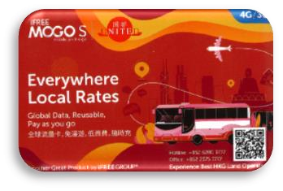

**KONG**

**Dapatkan Kartu Telpon International**

**KEBERANGKATAN : 01 NOV – 20 DEC 2019 (TRAVEL PERIOD)**

**ITINERARY 3H2M HONG KONG PRUDENTIAL HOTEL**

**HARI 1 : INDONESIA - HONG KONG**

Setibanya di Hong Kong International Airport anda akan dijemput oleh perwakilan kami dan berangkat menggunakan bus menuju hotel Prudential berlokasi di Nathan Road lalu check-in.

**HARI 2 : CITY TOUR HONG KONG**

Pagi hari anda akan dijemput di hotel lalu kita akan menuju restaurant DIMSUM Muslim Friendly (PORK FREE) dan mengunjungi tempat wisata seperti TsimShaTsui Promenade (Waterfront), Aberdeen Fishing Village, Victoria Peak Mid-level, Jewelry dan Souvenirs.

**FREE OPEN TOP BUS (SORE HARI) – drop off di Ladies Market atau Nathan Road (tamu pilih salah satu).**

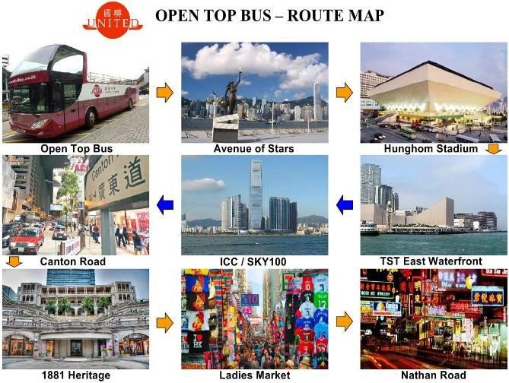

**HARI 3 : HONG KONG - INDONESIA**

Persiapan anda untuk check-out dari hotel hingga waktu keberangkatan. Perwakilan kami akan menjemput anda di hotel dan menuju HKIA. Terima Kasih atas kunjungan anda ke HKG Bersama.

**SYARAT DAN KETENTUAN**

1. CITY TOUR min GV2 based on Seat In Coach dan tour guide berbahasa Inggris
2. Tipping untuk driver dalam USD 7 atau dalam HKD 50 per orang dibayar di tempat
3. Service tours & hotel ini sifatnya non-refund setelah confirm dan pembayaran
4. Complimentary Sarapan HKG Dim Sum hanya bisa dapat di hari kedua sebelum City Tour dimulai.
5. GRATIS Open Top Bus Tour juga hanya bisa di ambil/digunakan pada hari ke-2 setelah Compulsory City Tour.
6. City Tour berakhir di Avenue of Star atau Ladies market, tamu balik ke hotel bisa menggunakan taxi/MRT (atas biaya sendiri).

HKIA Transfer berdasarkan SEAT IN COACH dimana servis tersebut berlaku diantara pukul 08.30 – 22.00 setiap hari. Diluar jadwal tersebut maka kita dapat menyediakan servis dengan Private coach (07) seven seats van @HKD 940/satu kali jalan atau (23) seat coach @HKD 1560/satu kali jalan – diantar ke daerah Kowloon.

|  |  |  |  |  |
| --- | --- | --- | --- | --- |
| **Hotel Name** | Period | *Fare in IDR /pax* | | |
| **3H2M** | EXTENDED ROOM/NITE | |
| Twin | Triple |
| **Prudential Hotel**  **(FREE Wifi)** | 01/Nov – 20/Dec | **Rp 1.275.000** | **Rp 1.335.000** | **Rp 1.920.000** |
| 01-30/Nov 2019 → NO weekend or Peak Day surcharge 01-20/Dec 2019 → USD15/twin/nite & USD23/Triple/nite | | | | |
| **Single Supplement** | **01/Nov – 20/Dec** | **Add** 100% of tour fare | | |
| **Child No Bed (2-11 yrs old)** | **Rp 525.000** | | |
| **Child with bed or Half Twin**  **(2-11 yrs old)** | Same fare as adult | | |

***Disneyland***

**ONE Day pass TWO Days pass Adult = HKD 624 HKD 741**



**Child = HKD 429 HKD 570**

**Senior = HKD 156 HKD 234**

**ONE DAY PASS WITH RETURN SIC TRANSFER**

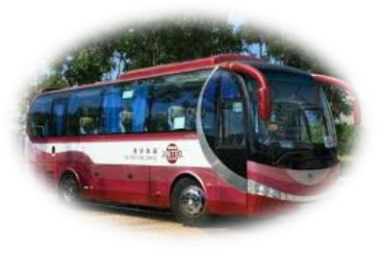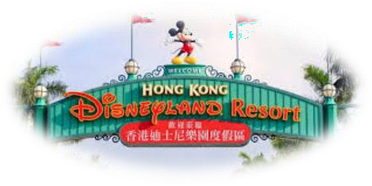**Adult = HKD 741 Child = HKD 546 Senior = HKD 273**

**Remarks :**

**Child = 3-11 years old Senior = 65 years above**

**Pick up time from Hotel ->Theme Park = 09:00-10:00 Depart from Theme Park ->Hotel = after night parade**

***Effectively 01 Oct – 20 Dec 2019***

**Ocean Park**

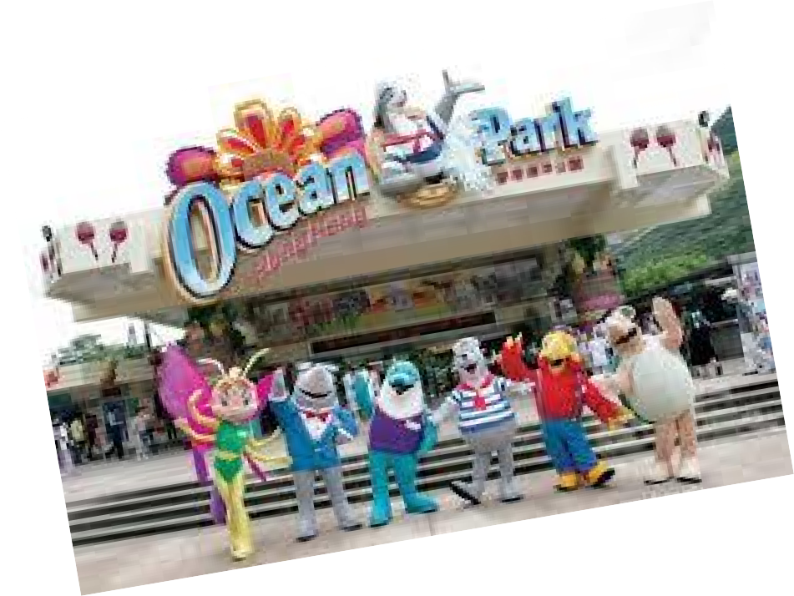

**only**



**ONE Day pass E-Ticket Adult = HKD 429 Child = HKD 273**

**ONE Day pass with return SIC transfer Adult = HKD 546**

**Child = HKD 390**

*Effectively 01 Oct – 20 Dec 2019*

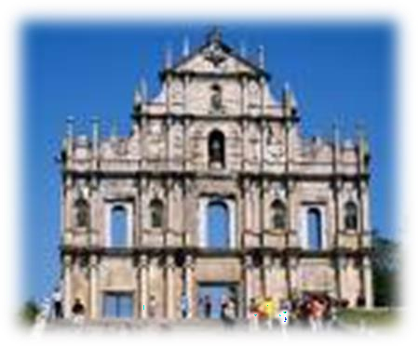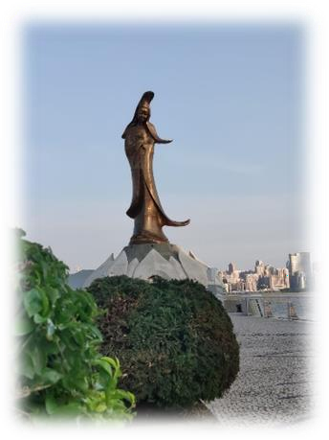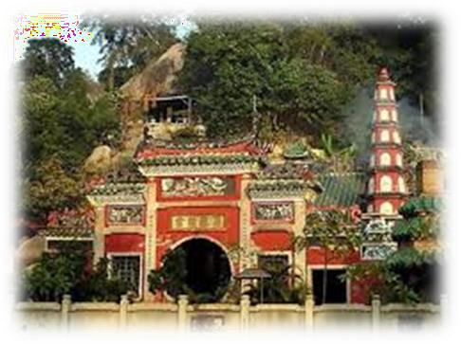

*MACAU DAY TOUR + LUNCH (02 PAXS UP)*

## Itinerary

**Visit The Ruins of St Paul, A-Ma Temple, KunLam Statue, Venetian Resort + 01 local product shop**

**Remarks :**

* **Adult/Child same fare**
* **Minimum booking 02 paxs**
* **Infant will be charge for 02 ways ticket only HKD 351/pax**
* **If need 03 hours free time at Venetian with simple dinner will add HKD 312/pax**
* **Fare include 02 ways ferry tickets + 01 way transfer from HKG Hotel (downtown area) to HKG ferry terminal**
* **All transfer will be based on Seat In Coach service**
* **Service end at Venetian Hotel.**

*Effectively 01 Oct – 20 Dec 2019*